# ASR 6989

**From:** Tran, Gia-My   
**Sent:** Tuesday, 27 February, 2018 2:29 PM  
**To:** Chan, Pei-Fong  
**Cc:** SG-DistList-SIN-SonyMobile-Outbound; Low, Dennis  
**Subject:** RE: Add shipping document codes in Delivery Order - ASR 6989

Hi Pei Fong,

For battery requirements, kindly refer as below. Please let me know if you have any inquires

* **In WMS system**, it has to show as

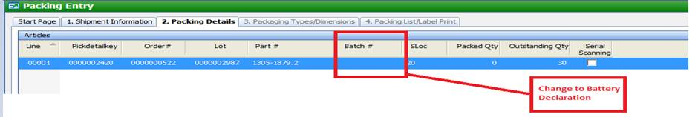

* **Pick Ticket**, it has to show as below

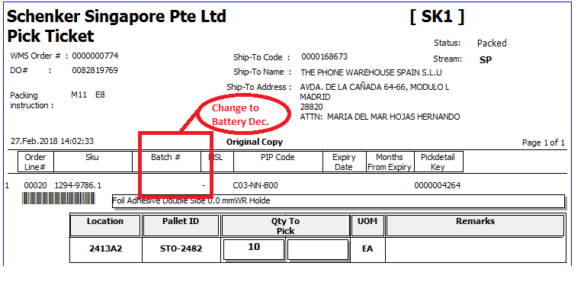

* **Packing List**, it has to show as below

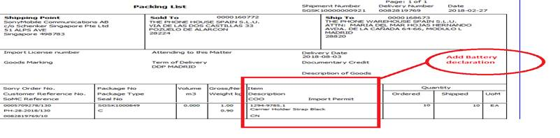

* **Delivery Order**, it has to show as below

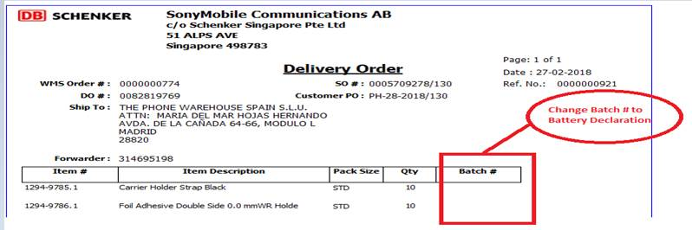

Best Regards,

Jia Mei (Ms)

Logistics Officer

SCHENKER SINGAPORE PTE LTD

51 ALPS Avenue

Singapore (498783)

DID: 65495852

# WMS Update:

2018.02.27

PROD:

Orderkey = 0000000512

select * from bax_pack_dtl where orderkey = '0000000512'

Packkey 0000000610

## Pick ticket

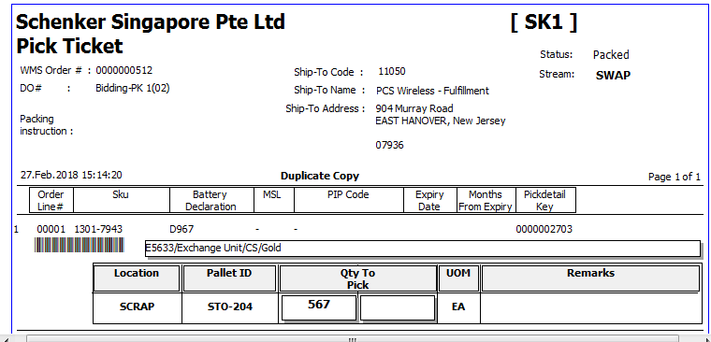

## Packing List

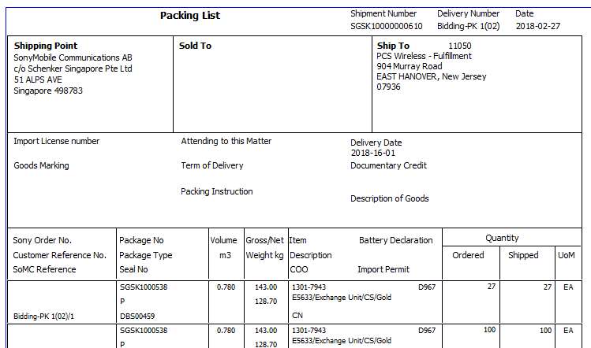

## Delivery Order

